AugStatic - A Light-Weight Image Augmentation Library

1Allena Venkata Sai Abhishek1, 2Dr. Venkateswara Rao Gurrala

1Research Scholar, 2Professor

1Department of Computer Science and Engineering,

1GITAM University, Visakhapatnam, Andhra Pradesh, India

________________________________________________________________________________________________________

*Abstract:*  The rapid exponential increase in the data led to an abrupt mix of various data types, leading to a deficiency of helpful information. Creating new data with the existing different types of data are presented in this paper. Augmentation is adding up or modifying the dataset with extra data. There are many types of augmentation done for various kinds of datasets. Augmentation has been widely used in multiple pre-processing steps of diverse machine learning pipelines. Many libraries or packages are made for augmentation called augmentation libraries. There are many salient features that each library supports. This paper seeks to enhance the library that makes the AugStatic library much more lightweight and efficient. AugStatic is a custom-built image augmentation library with lower computation costs and more extraordinary salient features compared to other image augmentation libraries. This framework can be used for NumPy array and tensors too.

*IndexTerms* – Albumentations, Augmentor, Imgaug, Data Augmentation, transformation, PyTorch, Tensorflow.

*______________________________________________________________________________________________________*

# **Introduction**

Data is so abruptly and exponentially increases day-to-day, which has created many complexities for image data. The data augmentation [4] [6] can be of various types, such as image, audio, NLP, and Time series. Every kind of augmentation is used for the same purpose of increasing the data. In this paper, the study is focused on image data augmentation. Many libraries support the image data augmentation with various input and output, such as Numpy array and tensors [9].

There are many methods used for various use cases. For example, image matting [5] extracts the foreground in an image. Mixup Augmentation [3] is used for smoothening the photos.

Machine learning is a field of Artificial intelligence that is a perspective on helping machines learn and build their pipeline to work on their way of decision making. It is achieved with as minimal human collaboration as could be expected, for example, without the requirement for human intercession.

Artificial intelligence is a part of artificial consciousness. The educational experience is robotized and worked on over the long haul because of the encounters with machines. Excellent information and an assortment of approaches are given to PCs to fabricate or develop AI models. The calculation to still up in the air of the sort of information and the task to be computerized.

Data pre-processing [11] is the process of modifying the input dataset to make it more suitable for the training and testing sets of the dataset. It helps to alter the data into the required format for the model to read. Many corporates use machine learning pipelines. And machine learning pipelines include pre-processing steps. There is a need to mold the data into a suitable format before feeding it to the model, for which data augmentation is used.

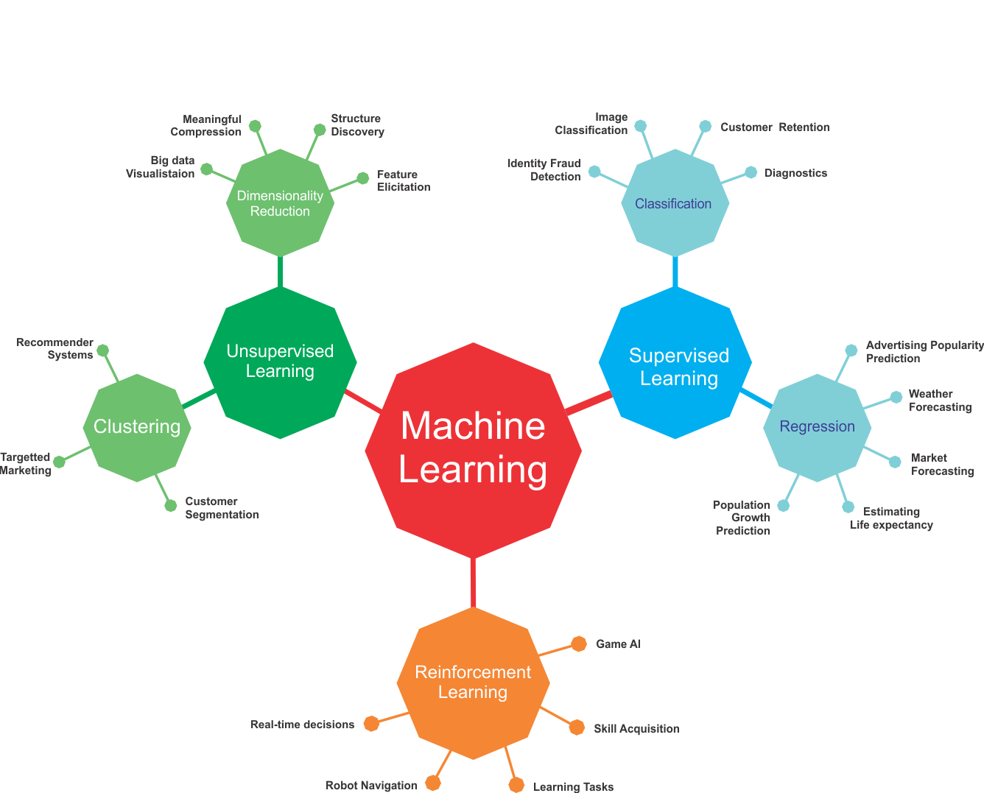

**Fig-1: Machine Learning**

Data pre-processing is essential before the data can be used. Data preprocessing is changing the crude data into a clean dataset collection. Before executing the calculation, the dataset is preprocessed to look at missing qualities, boisterous information, and different irregularities.

A Machine learning pipeline is a method for arranging and robotizing the work process it takes to deliver an AI model. Machine learning pipelines comprise various successive advances that do everything from information extraction and preprocessing to show deployment after the training.

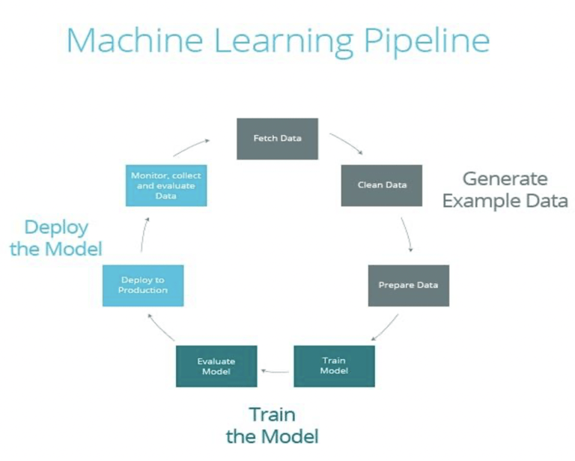

**Fig-2: Machine learning pipeline**

The advantage of using data augmentation is that it is time-saving & cost-effective. The dataset size can be increased with the existing data; hence, it saves time searching the data. The augmentation is an integral part of many machine learning pipelines. We can also incorporate it in generating the new synthetic images done in General Adversarial Network (GANs) [7].

**Fig-3: Data Augmentation**

# **Background work**

Many data augmentations were researched, as shown in fig.3. The data augmentations can be some on audio, text, audio, and time series. The image augmentation library is being researched in this paper, and many libraries such as imgaug [12], albumentations [10], and augmentor [2] were extensively compared. Few take input as a NumPy array, and some in tensors. A tensor can be incorporated as a multidimensional array that can be generalized as vectors and matrices. The advantage of using data augmentation is that it is time-saving & cost-effective. Various types of augmentations were researched and compiled into a compact, lightweight, and practical library.

The salient feature of Imgaug package –

* It contains over forty image augmentation techniques
* Functionality to augment images with masks, key points, bounding boxes, and heat maps.
* Easier to augment the image dataset for object detection and segmentation problems
* Complex augmentation pipelines
* Many helper functions for augmentation visualization, conversion, and more.

The salient feature of Augmentor package –

* It has fewer possible augmentations compared to other packages
* It supports extra features like size-preserving shearing, size-preserving rotations, and cropping, which is beneficial for machine learning pipelines.
* It supports to compose augmentation pipelines
* It supports usage with PyTorch [8] and Tensorflow [1].

The salient feature of Albumentations package –

* It contains over forty image augmentation techniques
* Functionality to augment images with masks, key points, bounding boxes, and heat maps.
* Easier to augment the image dataset for object detection and segmentation problems
* Complex augmentation pipelines
* Many helper functions for augmentation visualization, conversion, and more.

# https://lh6.googleusercontent.com/J3l35O3qKDMr3-Bj2zKQonXiDGlGyJCuPXTGnWtXT4gx69O5MPJiKvmZxFYbcFC3e_ss9sTZA1B5Be96qfWvQZtGQleZwnL5aKl8uW524_nlOZkZG85Z5nacPBSzAq-GmYWb_oy-

**Fig-4: Augmentation Techniques**

# **Research Methodology**

Different data needs different types of augmentations. The image data can be augmented using shift, rotate scale, etc. There are affine transformations [14] in which the edges of the object of interest do not change. There are perspective transformations [15] & spatial level transformations such as shear transformation.

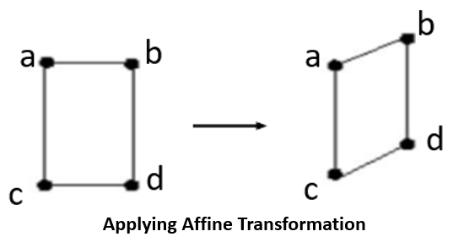

**Fig-5: Affine Transformation Augmentation Techniques**

Many types of data augmentations were researched, as shown in fig.3. The data augmentations can be some on audio, text, audio, and time series. The image augmentation library is being researched in this paper, and many libraries such as imgaug, albumentations, and augmentor were extensively compared. Few data augmentation libraries of images take up the input as a NumPy array and some in tensors. The advantage of using data augmentation is that it is time-saving & cost-effective. Various augmentations were researched and compiled into a compact, lightweight, and efficient library.

These are the list of augmentations supported by the Augstatic library –

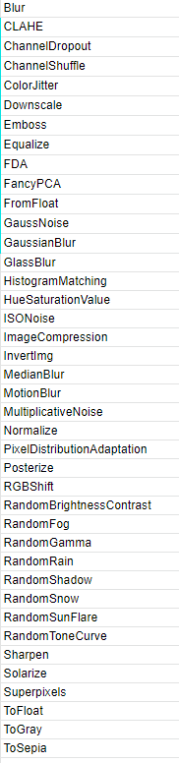

**Fig-6: Supported Augmentations by AugStatic library**

The Augstatic library is a lightweight augmentation library that is used for images. The input is a NumPy array and has all the features of previously mentioned augmentation libraries. The library is lightweight because, unlike PyTorch, and Keras [13], transforms, there is no need to convert the image array into tensors. It reduces the computational cost and latency of the pre-processing step of data augmentation.

# **Results and Discussions**

The lightweight and efficient image augmentation library named AugStatic is developed in this paper. AugStatic is a readily used augmentation library that supports all the augmentations of PyTorch, Keras, Imgaug, Albumentations, and Augmentor. We can keep adding more features with the advancement in augmentation.

It can be used as the one place solution for all the augmentations supported by various augmentation libraries for images. It takes the NumPy image array as an input and returns the augmented images in NumPy array format. It is flexible and easily scalable.

These are some of the outputs generated by the augmentation library -

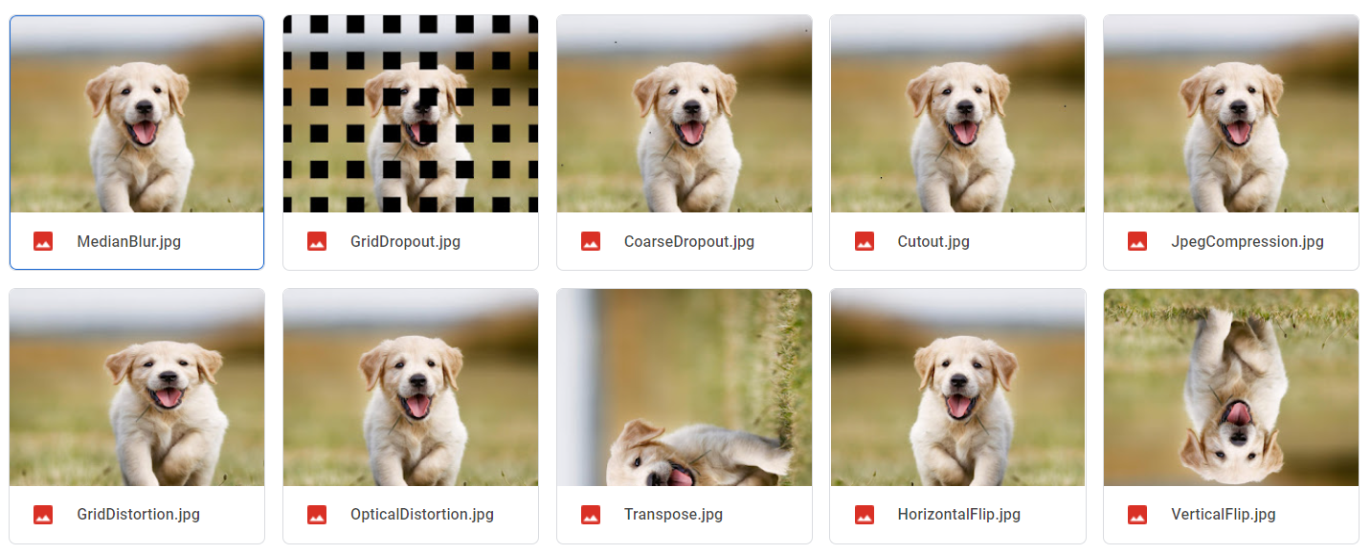

**Fig-7: Output -1 of Supported Augmentations by AugStatic library**

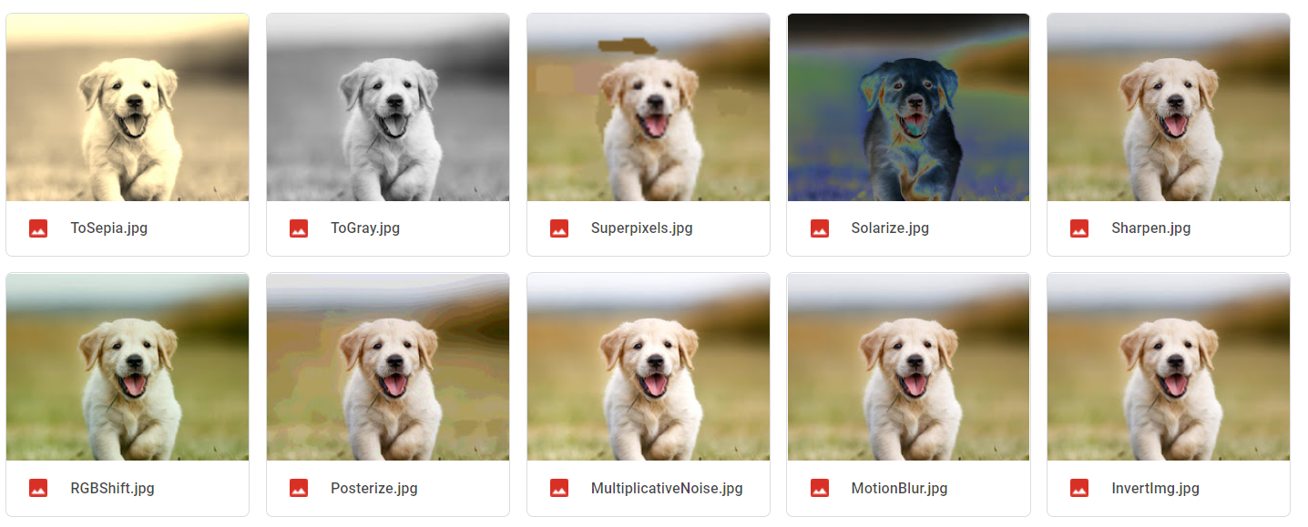

**Fig-8: Output -2 of Supported Augmentations by AugStatic library**

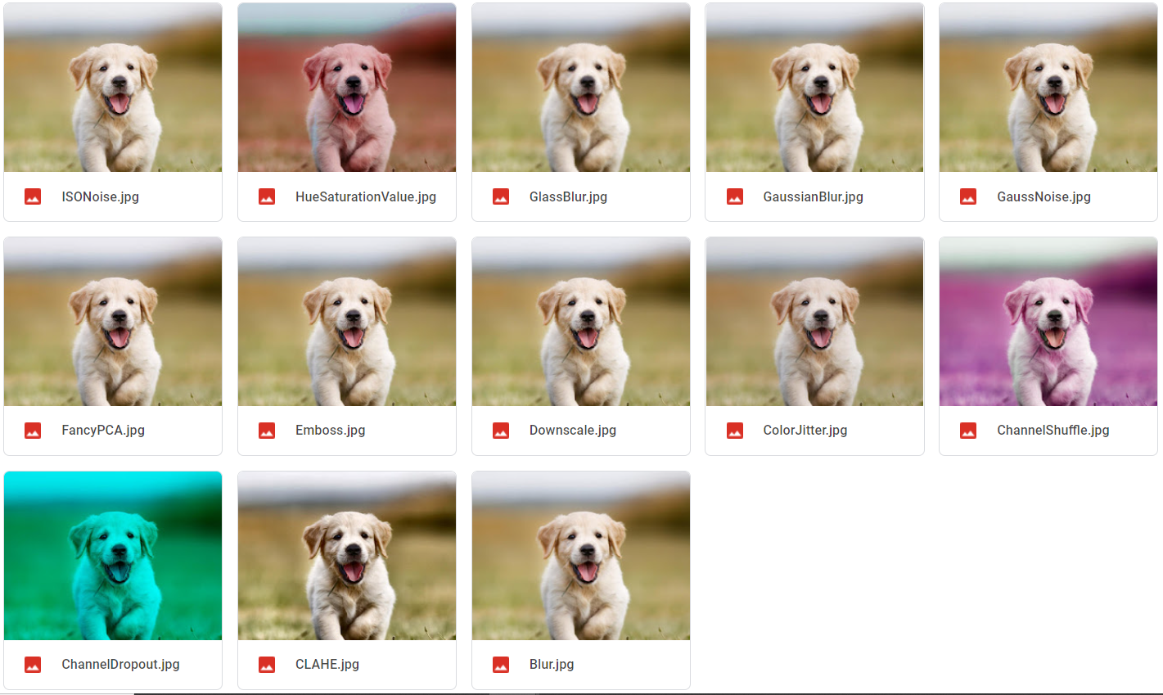

**Fig-9: Output -3 of Supported Augmentations by AugStatic library**

# **Conclusion and Future Scope**

Data augmentation is crucial to any machine learning pipeline. A lightweight with less computational cost compared to other augmentation libraries is developed and demonstrated in this paper. An efficient image augmentation library named AugStatic is a custom built image augmentation library which supports all the augmentations of PyTorch, Keras, Imgaug, Albumentations and Augmentor. It is built on python and is easily understandable and flexible enough to keep adding features. Hence, making it more scalable. With the advancement in augmentation, there is a lot of scope in making the AugStatic library for audio, NLP, and time-series data.

# **References**

1. Martín Abadi, Ashish Agarwal, Paul Barham, Eugene Brevdo, Zhifeng Chen, Craig Citro, Greg S. Corrado, Andy Davis, Jeffrey Dean, Matthieu Devin, Sanjay Ghemawat, Ian Goodfellow, Andrew Harp, Geoffrey Irving, Michael Isard, Yangqing Jia, Rafal Jozefowicz, Lukasz Kaiser, Manjunath Kudlur, Josh Levenberg, Dan Mane, Rajat Monga, Sherry Moore, Derek Murray, Chris Olah, Mike Schuster, Jonathon Shlens, Benoit Steiner, Ilya Sutskever, Kunal Talwar, Paul Tucker, Vincent Vanhoucke, Vijay Vasudevan, Fernanda Viegas, Oriol Vinyals, Pete Warden, Martin Wattenberg, Martin Wicke, Yuan Yu, Xiaoqiang Zheng 2016. “TensorFlow: Large-Scale Machine Learning on Heterogeneous Distributed Systems” arXiv:1603.04467 [cs.DC]

**[2]** Marcus D. Bloice, Christof Stocker, Andreas Holzinger. 2017. “Augmentor: An Image Augmentation Library for Machine Learning” arXiv:1708.04680v1 [cs.CV]

**[3]** Hongyi Zhang, Moustapha Cisse, Yann N. Dauphin, David Lopez-Paz. 2018. “MixUp augmentation for image classification”arXiv:1710.09412v2 [cs.LG]

**[4]** Zhiting Hu, Bowen Tan, Ruslan Salakhutdinov, Tom Mitchell, Eric P. Xing. 2019. “Learning Data Manipulation for Augmentation and Weighting “ arXiv:1910.12795v1 [cs.LG]

**[5]** Shanchuan Lin, Linjie Yang, Imran Saleemi, Soumyadip Sengupta. 2021. “Robust High-Resolution Video Matting with Temporal Guidance” arXiv:2108.11515v1 [cs.CV]

**[6]** Connor Taghi M. Khoshgoftaar. 2019. “A survey on Image Data Augmentation for Deep Learning” Shorten and Khoshgoftaar J Big Data

**[7]** Ian J. Goodfellow, Jean Pouget-Abadie, Mehdi Mirza, Bing Xu, David Warde-Farley, Sherjil Ozair, Aaron Courville, Yoshua Bengio “Generative Adversarial Networks “ arXiv:1406.2661v1 [stat.ML]

**[8]** Adam Paszke, Sam Gross, Francisco Massa, Adam Lerer, James Bradbury, Gregory Chanan, Trevor Killeen, Zeming Lin, Natalia Gimelshein, Luca Antiga, Alban Desmaison, Andreas Köpf, Edward Yang, Zach DeVito, Martin Raison, Alykhan Tejani, Sasank Chilamkurthy, Benoit Steiner, Lu Fang, Junjie Bai, Soumith Chintala. 2019. “PyTorch: An Imperative Style, High-Performance Deep Learning Library” arXiv:1912.01703 [cs.LG]

**[9]** Dimitrios Koutsoukos, Supun Nakandala, Konstantinos Karanasos, Karla Saur, Gustavo Alonso , Matteo Interlandi “Tensors: An abstraction for general data processing.”

**[10]** Alexandr A. Kalinin, Vladimir I. Iglovikov, Eugene Khvedchenya, Alex Parinov, Alexander Buslaev. 2020. “Albumentations: fast and flexible image Augmentations”

**[11]** Sujith Jayaprakash Balamurugan E. 2015. A Comprehensive Survey on Data Preprocessing Methods in Web Usage Mining.

**[12]** “Augmentation methods applied to data using imgaug library.”, https://github.com/aleju/imgaug

**[13]** Ketkar, Nikhil. (2017). “Introduction to Keras.” 10.1007/978-1-4842-2766-4_7.

**[14]** Coste, Arthur. (2012). Image Processing: Affine Transformation, Landmarks registration, Nonlinear Warping. 10.13140/RG.2.2.13653.27360.

**[15]** Mezirow J. Perspective Transformation. Adult Education. 1978;28(2):100-110. doi:10.1177/074171367802800202